**HUMIDEX SENSOR**

**(Heat Index, Humidity and Temperature)**

RAMAIAH

Institute of

Technology

nology

**Department of Computer Science and Engineering**

***Mini Project Report***

**Subject Name/Code: Analog and Digital Circuits/CS1531**

**Term: Aug-Dec 2016**

**Section: III ‘B’**

|  |  |  |
| --- | --- | --- |
| **Title of the Project** | **HUMIDEX SENSOR**  **( Heat Index, Humidity and Temperature)** | |
| **S. No** | **Name of the Student** | **USN** |
|  | **PRASHANT KRISHNAN V** | **1MS15CS091** |
|  | **M.V.S. VISWANADH** | **1MS15CS074** |
|  | **PRABHULING** | **1MS15CS090** |
|  | **SANJU C.G.** | **1MS16CS426-T** |
| **Name of the Faculty** | **Mrs. APARNA. R** | |

**Signature of the Faculty**

**TABLE OF CONTENTS**

Page No.

1. Introduction 3
2. Components Used 4
3. Circuit Diagram 5
4. Source Code 6
5. DHT 11 Humidity and Temperature Sensor 10
6. Heat Index 12
7. Working Principle and Output 14
8. Conclusion 17

**INTRODUCTION**

This project consists of a device which measures the Heat Index and also the Humidity, Temperature of the surroundings. An Arduino Uno board is being used here, to which a DHT11 sensor is connected. This is a Temperature & Humidity Sensor which features a complex detector with a calibrated digital signal output. This sensor includes a resistive-type humidity measurement component and an NTC temperature measurement component**.** The DHT11 sensor is connected to the Uno using a breadboard.

The device acts like a remote mini weather station. There are LEDs that are present which light up with different colours, depending on the temperature and the humidity of the surroundings. With the information that is being obtained from the DHT11 sensor, we calculate the Heat Index of the surroundings. The heat index was developed in 1978 by George Winterling. The computation of the heat index is a refinement of a result obtained by multiple regression analysis carried out by Lans P. Rothfusz and Robert G. Steadman. The **heat index** (**HI**) or **humiture** or **humidex,** sometimes referred to as the apparent temperature, is a measure of how hot it really feels when relative humidity is factored with the actual air temperature. This can be very handy, in shaded areas. As, the Heat Index tells the temperature actually felt by the person and it’s thus also called “felt air temperature”.

**COMPONENTS USED**

1. Arduino Uno
2. Bread Board
3. RGB LEDs
4. 270 ohm Resistors
5. DHT11 Temperature and Humidity Sensor
6. Jumper wires
7. Connecting wires

**CIRCUIT DIAGRAM**

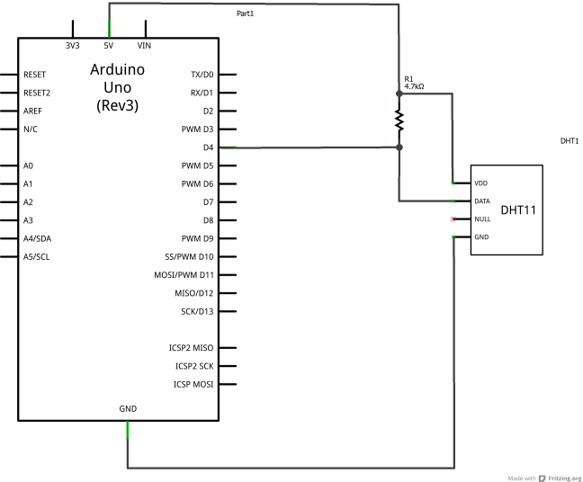

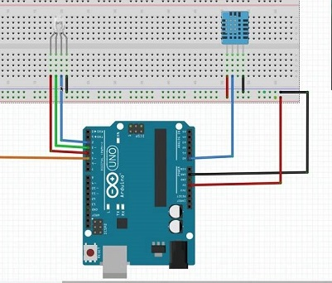

**SOURCE CODE**

#include <dht.h>

dht DHT;

#define DHT11_PIN 7

#define pin2 1

#define pin3 2

#define pin4 3

int redPin = 11;

int greenPin = 10;

int bluePin = 9;

void setup()

{

pinMode(redPin, OUTPUT);

pinMode(greenPin, OUTPUT);

pinMode(bluePin, OUTPUT);

Serial.begin(9600);

}

void setColor(int red, int green, int blue)

{

#ifdef COMMON_ANODE

red = 255 - red;

green = 255 - green;

blue = 255 - blue;

#endif

analogWrite(redPin, red);

analogWrite(greenPin, green);

analogWrite(bluePin, blue);

}

void loop()

{

int chk = DHT.read11(DHT11_PIN);

double c1=-42.379,c2=2.04901523,c3=10.14333127,c4=-0.22475541;

double c5=-0.00683783,c6=-0.05481717,c7=0.00122874,c8=0.00085282,c9=-0.00000199;

double HI,f;

Serial.print("\nTemperature = ");

Serial.println(DHT.temperature);

Serial.print("\nHumidity = ");

Serial.println(DHT.humidity);

f=((1.8*DHT.temperature)+32);

HI=(c1)+(c2*f) + (c3*DHT.humidity) + (c4*f*DHT.humidity ) + (c5*f*f) + (c6*DHT.humidity*DHT.humidity) + (c7*f*f*DHT.humidity) + (c8*f*DHT.humidity*DHT.humidity) + (c9*f*f*DHT.humidity*DHT.humidity);

HI=(HI-32)*5/9;

Serial.print("\nHEAT INDEX = ");

Serial.print(HI);

if(DHT.humidity>45)

{

setColor(255, 0, 0);

Serial.print("\nHumidity is greater than 45. Green light\n");

}

delay(2000);

if(DHT.temperature>23)

{

setColor(0, 255, 0);

Serial.print("\nTemperature is greater than 23. Red light\n");

}

delay(2000);

if(DHT.temperature>22 && DHT.humidity>65)

{

Serial.print("\nTemperature is greater than 22 and Humidity greater than 65.\n");

setColor(255, 0, 0); // red

delay(500);

setColor(0, 255, 0); // green

delay(500);

setColor(0, 0, 255); // blue

delay(500);

setColor(255, 255, 0); // yellow

delay(500);

setColor(80, 0, 80); // purple

delay(500);

setColor(0, 255, 255); // aqua

delay(500);

}

delay(2000);

}

**EXPLANATION OF THE CODE**

* **#include <dht.h> :** The header file which is included for the DHT11 humidity and temperature sensor.
* The sketch starts by specifying which pins are going to be used for the sensor and for each of the colors.
* **setup( ) :** This function runs just once the Arduino is reset. It defines the three pins that we’re using for the LEDs as outputs.
* **setColor(int red, int green, int blue) :** This function takes three arguments, one for the brightness of the red, green and blue LEDs. In each case the number will be in the range 0 to 255, where 0 means off and 255 means maximum brightness. The function then calls 'analogWrite' to set the brightness of each LED.
* **HI :** This variable is used to calculate the Heat Index.

**DHT 11 HUMIDITY AND TEMPERATURE SENSOR**

The DHT11 is a basic, ultra low-cost digital temperature and humidity sensor. It uses a capacitive humidity sensor and a thermistor to measure the surrounding air, and spits out a digital signal on the data pin (no analog input pins needed). This DFRobot DHT11 Temperature & Humidity Sensor features a temperature & humidity sensor complex with a calibrated digital signal output. By using the exclusive digital-signal-acquisition technique and temperature & humidity sensing technology, it ensures high reliability and excellent long-term stability. This sensor includes a resistive-type humidity measurement component and an NTC temperature measurement component, and connects to a high performance 8-bit microcontroller, offering excellent quality, fast response, anti-interference ability and cost-effectiveness.

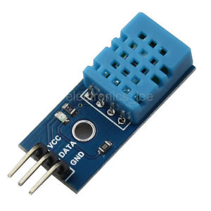

**SPECIFICATIONS:**

* Temperature Measurement range : 0-50 ℃
* Humidity Measurement range : 20-90% RH
* Humidity Accuracy : ±5% RH
* Temperature Accuracy : ±2% ℃

**FEATURES:**

* Low cost
* 3 to 5V power and I/O
* 2.5mA max current use during conversion (while requesting data)
* Good for 20-80% humidity readings with 5% accuracy
* Good for 0-50°C temperature readings ±2°C accuracy
* No more than 1 Hz sampling rate (once every second)
* Body size 15.5mm x 12mm x 5.5mm
* 4 pins with 0.1" spacing

**HEAT INDEX**

The **heat index** (**HI**) or **humiture** or **humidex**  is an index that combines [air](https://en.wikipedia.org/wiki/Air) [temperature](https://en.wikipedia.org/wiki/Temperature) and [relative humidity](https://en.wikipedia.org/wiki/Relative_humidity), in shaded areas, as an attempt to determine the human-perceived equivalent temperature, as how hot it would feel if the [humidity](https://en.wikipedia.org/wiki/Humidity) were some other value in the shade. The result is also known as the "felt air temperature" or "[apparent temperature](https://en.wikipedia.org/wiki/Apparent_temperature)". For example, when the temperature is 32 °C (90 °F) with 70% relative humidity, the heat index is 41 °C (106 °F). This heat index temperature has an implied (unstated) humidity of 20%. This is the value of relative humidity for which the heat index formula indicates 41 °C feels like 41 °C. A heat index temperature of 32 °C has an implied relative humidity of 38%.

The human body normally cools itself by [perspiration](https://en.wikipedia.org/wiki/Perspiration), or sweating. [Heat](https://en.wikipedia.org/wiki/Heat) is removed from the body by [evaporation](https://en.wikipedia.org/wiki/Evaporation) of that sweat. However, high relative humidity reduces the evaporation rate. This results in a lower rate of heat removal from the body, hence the sensation of being overheated. This effect is subjective, with different individuals perceiving heat differently for various reasons (such as [obesity](https://en.wikipedia.org/wiki/Obesity), metabolic differences, [pregnancy](https://en.wikipedia.org/wiki/Pregnancy), [menopause](https://en.wikipedia.org/wiki/Menopause), effects of drugs and/or [drug withdrawal](https://en.wikipedia.org/wiki/Drug_withdrawal)); its measurement has been based on subjective descriptions of how hot subjects feel for a given temperature and humidity. This results in a heat index that relates one combination of temperature and humidity to another.

**FORMULA:**

The formula below approximates the heat index in degrees Fahrenheit, to within ±1.3 °F.

**HI = c1 + c2T + c3R + c4TR + c5T2 + c6R2 + c7T2R + c8TR2 + c9T2R2**

Where,

**HI**{\displaystyle \mathrm {HI} \,\!} = heat index (in degrees Fahrenheit)

{\displaystyle T\,\!} **T** = temperature (in degrees Fahrenheit)

{\displaystyle R\,\!} **R** = relative humidity (percentage value between 0 and 100)

The set of constants and their values are :

**c1 =** - 42.379, **c2 =** 2.04901523, **c3 =** 10.14333127, **c4 = -** 0.22475541

**c5 = -** 0.00683783, **c6 = -** 0.05481717, **c7 =** 0.00122874, **c8 =** 0.00085282

**c9 = -** 0.00000199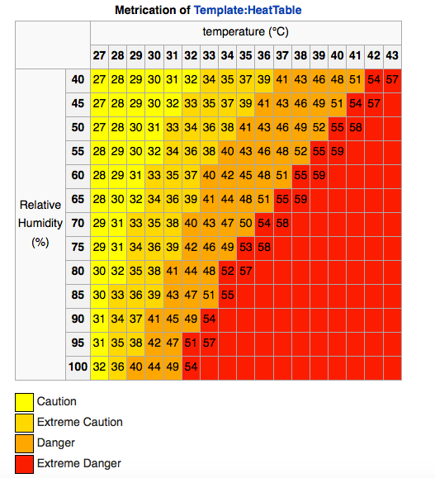

**How the DHT11 Measures Humidity and Temperature**

The DHT11 calculates relative humidity by measuring the electrical resistance between two electrodes. The humidity sensing component of the DHT11 is a moisture holding substrate (usually a salt or conductive plastic polymer) with the electrodes applied to the surface. When water vapour is absorbed by the substrate, ions are released by the substrate which increases the conductivity between the electrodes. The change in resistance between the two electrodes is proportional to the relative humidity. Higher relative humidity decreases the resistance between the electrodes while lower relative humidity increases the resistance between the electrodes. Inside the DHT11 you can see electrodes applied to a substrate on the front of the chip:

[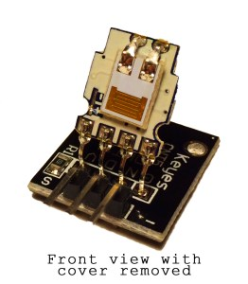](http://i2.wp.com/www.circuitbasics.com/wp-content/uploads/2015/09/DHT11-Temperature-and-Humidity-Sensor-Inside-Front-with-Cover-Removed.jpg)

The DHT11 converts the resistance measurement to relative humidity on an IC mounted to the back of the unit and transmits the humidity and temperature readings directly to the Arduino. This IC also stores the calibration coefficients and controls the data signal transmission between the DHT11 and the Arduino:

[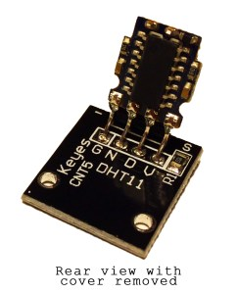](http://i0.wp.com/www.circuitbasics.com/wp-content/uploads/2015/09/DHT11-Temperature-and-Humidity-Sensor-Inside-Back-with-Cover-Removed.jpg)

The temperature readings from the DHT11 come from a surface mounted NTC temperature sensor (thermistor) built into the unit.

The DHT11 uses one signal wire to transmit sensor readings to the Arduino digitally. The power comes from separate 5V and ground wires. A 5K – 10K Ohm pull-up resistor is connected from the signal line to 5V to make sure the signal level stays high by default (see the datasheet for specifics on how the signal is sent).

There are two different variations of the DHT11 sensor you might come across. One type has four pins, and the other type is mounted to a small PCB that has three pins. The PCB mounted version with three pins is nice since it includes a surface mounted 10K Ohm pull up resistor for the signal line:

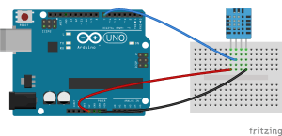

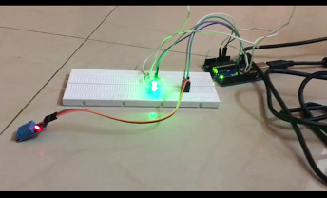

**Circuit connections with the Arduino**

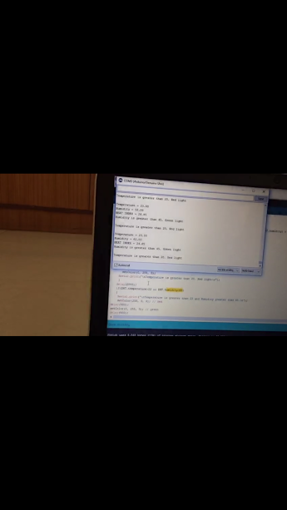

**Output**

**CONCLUSION**

* The Humidex Sensor is a simple prototype for a device which measures the Heat Index, Humidity and Temperature of the surroundings. It is low cost and portable.
* As mentioned above, it is a simple prototype and it’s practical applications are many. It can be used as a remote mini weather station. A remote station which gives you data regarding temperature, humidity and with the corresponding LED lights, it makes it easier to visually assimilate data.
* It can be used as a home environment system or an agricultural/garden monitoring systems.
* On household level, these sensors can be quite helpful in monitoring the compost bin. They can be used to check the moisture levels in the organic wastes and thus help in making the compost more reliable and efficient.
* On a large scale level, this could help the agricultural industry, as farmers could monitor the soil moisture content and hence, modify it for better yields for their produce.